|  |  |
| --- | --- |
| **Ex no : 3** | **Hyper Parameter tuning in Multilayer Perceptron** |
| **Date :** |

**Aim**

To implement multi-layer network for MNIST dataset with different hyper parameters and visualizing the comparison

**Basic Theory of Hyper Parameters.**

* + Hyperparameters are parameters whose values control the learning process and determine the values of model parameters that a learning algorithm ends up learning
  + The prefix ‘hyper_’ suggests that they are ‘top-level’ parameters that control the learning process and the model parameters that result from it.
  + The hyperparameters that were used during training are not part of this model
  + Parameters considered as a hyper parameters in this program are

1. Choosing activation function
2. Choosing no of epochs
3. Choosing validation split
4. Choosing the optimizer
5. Choosing learning rate

**PROCEDURE AND CODE**

|  |  |  |  |  |
| --- | --- | --- | --- | --- |
|  | **Scenario 1** | **Scenario 2** | **Scenario 3** | **Scenario 4** |
| Activation function (Only for Hidden Layers) | Sigmoid | Relu | Tanh | Sigmoid |
| No of Epochs | 24 | 25 | 21 | 23 |
| Validation Split | 0.3 | 0.2 | 0.1 | 0.2 |
| Optimizer | Adagrad | Adam | Adadelta | Adam |
| Learning Rate | 0.001 | 0.001 | 0.001 | 0.001 |

**Code for Scenario 1**

import tensorflow

from tensorflow import keras

from tensorflow.keras import Sequential

from tensorflow.keras.layers import Dense,Flatten

X_train,y_train),(X_test,y_test)= keras.datasets.mnist.load_data()

X_test.shape

X_train.shape

y_train.shape

y_test.shape

y_train

import matplotlib.pyplot as plt

plt.imshow(X_train[2])

X_train = X_train/255

X_test = X_test/255

X_train[0]

model = Sequential()

model.add(Flatten(input_shape=(28,28)))

model.add(Dense(128,activation='Sigmoid'))

model.add(Dense(32,activation=' Sigmoid '))

model.add(Dense(10,activation='softmax'))

model.summary()

model.compile(loss='sparse_categorical_crossentropy', optimizer=' Adagrad',metrics=['accuracy'])

history_scenario1=model.fit(X_train,y_train,epochs=24, validation_split=0.3)

y_prob = model.predict(X_test)

y_pred = y_prob.argmax(axis=1)

from sklearn.metrics import accuracy_score

accuracy_score(y_test,y_pred)

plt.plot(history_scenario1.history_scenario1['loss'])

plt.plot(history_scenario1.history_scenario1['val_loss'])

plt.plot(history_scenario1.history_scenario1['accuracy'])

plt.plot(history_scenario1.history_scenario1['val_accuracy'])

**Code for Scenario 2**

import tensorflow

from tensorflow import keras

from tensorflow.keras import Sequential

from tensorflow.keras.layers import Dense,Flatten

X_train,y_train),(X_test,y_test)= keras.datasets.mnist.load_data()

X_test.shape

X_train.shape

y_train.shape

y_test.shape

y_train

import matplotlib.pyplot as plt

plt.imshow(X_train[2])

X_train = X_train/255

X_test = X_test/255

X_train[0]

model = Sequential()

model.add(Flatten(input_shape=(28,28)))

model.add(Dense(128,activation='Relu'))

model.add(Dense(32,activation='Relu'))

model.add(Dense(10,activation='softmax'))

model.summary()

model.compile(loss='sparse_categorical_crossentropy', optimizer='Adam',metrics=['accuracy'])

history_scenario1=model.fit(X_train,y_train,epochs=25, validation_split=0.2)

y_prob = model.predict(X_test)

y_pred = y_prob.argmax(axis=1)

from sklearn.metrics import accuracy_score

accuracy_score(y_test,y_pred)

plt.plot(history_scenario1.history_scenario1['loss'])

plt.plot(history_scenario1.history_scenario1['val_loss'])

plt.plot(history_scenario1.history_scenario1['accuracy'])

plt.plot(history_scenario1.history_scenario1['val_accuracy'])

**Code for Scenario 3**

import tensorflow

from tensorflow import keras

from tensorflow.keras import Sequential

from tensorflow.keras.layers import Dense,Flatten

X_train,y_train),(X_test,y_test)= keras.datasets.mnist.load_data()

X_test.shape

X_train.shape

y_train.shape

y_test.shape

y_train

import matplotlib.pyplot as plt

plt.imshow(X_train[2])

X_train = X_train/255

X_test = X_test/255

X_train[0]

model = Sequential()

model.add(Flatten(input_shape=(28,28)))

model.add(Dense(128,activation='Tanh'))

model.add(Dense(32,activation='Tanh'))

model.add(Dense(10,activation='softmax'))

model.summary()

model.compile(loss='sparse_categorical_crossentropy', optimizer='Adadelta',metrics=['accuracy'])

history_scenario1=model.fit(X_train,y_train,epochs=21, validation_split=0.1)

y_prob = model.predict(X_test)

y_pred = y_prob.argmax(axis=1)

from sklearn.metrics import accuracy_score

accuracy_score(y_test,y_pred)

plt.plot(history_scenario1.history_scenario1['loss'])

plt.plot(history_scenario1.history_scenario1['val_loss'])

plt.plot(history_scenario1.history_scenario1['accuracy'])

plt.plot(history_scenario1.history_scenario1['val_accuracy'])

**Code for Scenario 4**

import tensorflow

from tensorflow import keras

from tensorflow.keras import Sequential

from tensorflow.keras.layers import Dense,Flatten

X_train,y_train),(X_test,y_test)= keras.datasets.mnist.load_data()

X_test.shape

X_train.shape

y_train.shape

y_test.shape

y_train

import matplotlib.pyplot as plt

plt.imshow(X_train[2])

X_train = X_train/255

X_test = X_test/255

X_train[0]

model = Sequential()

model.add(Flatten(input_shape=(28,28)))

model.add(Dense(128,activation='Sigmoid'))

model.add(Dense(32,activation=' Sigmoid '))

model.add(Dense(10,activation='softmax'))

model.summary()

model.compile(loss='sparse_categorical_crossentropy', optimizer=' Adam',metrics=['accuracy'])

history_scenario1=model.fit(X_train,y_train,epochs=23, validation_split=0.2)

y_prob = model.predict(X_test)

y_pred = y_prob.argmax(axis=1)

from sklearn.metrics import accuracy_score

accuracy_score(y_test,y_pred)

plt.plot(history_scenario1.history_scenario1['loss'])

plt.plot(history_scenario1.history_scenario1['val_loss'])

plt.plot(history_scenario1.history_scenario1['accuracy'])

plt.plot(history_scenario1.history_scenario1['val_accuracy'])

**OUTPUT**

Training Accuracy

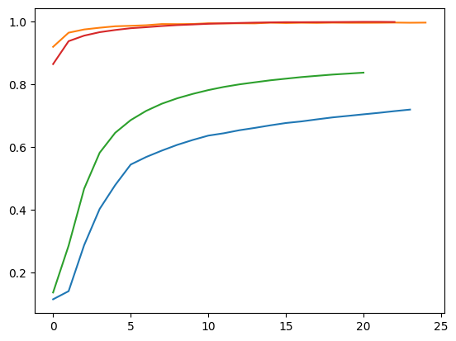

Training Loss

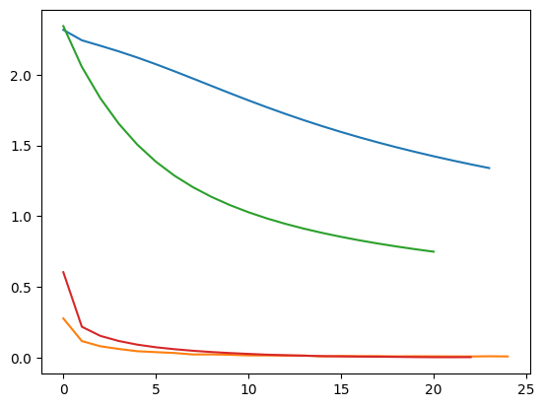

Validation Accuracy

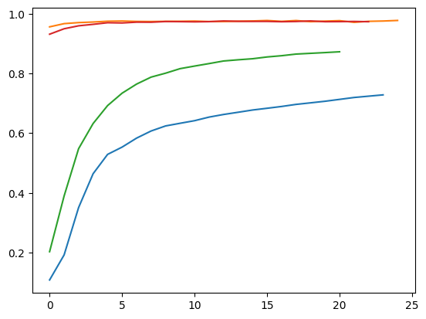

Validation Loss

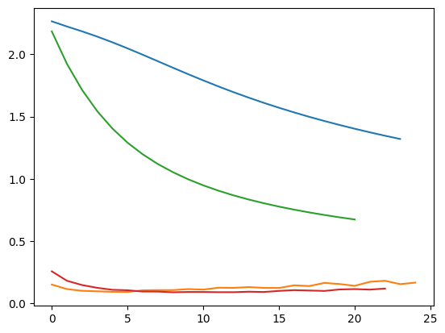

**RESULT**

Thus implementation of multi-layer network for MNIST dataset with different hyper parameters and visualizing the comparison has been carried out successfully.